**Part 1: Configuring Dragino Gateway and Uploading Sketch from Arduino IDE:**

Step 1: Connect external power supply to Dragino LG01-p Gateway

Step 2: Look for “dragino-171700” SSID in available WIFI networks and connect to it

Step 3: Go to browser and type in 10.130.1.1

Step 4: When prompted for login, enter “dragino” as password

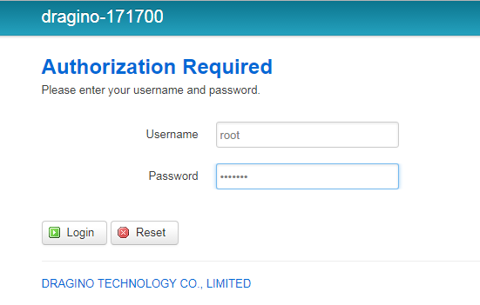

Step 5: At top of Dragino’s user interface go to Network ->Internet Access

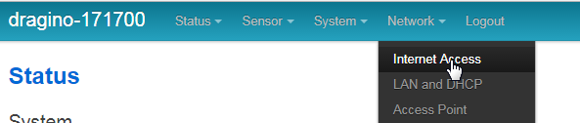

Step 6: Select WiFi Client via the Access Internet Via drop down menu

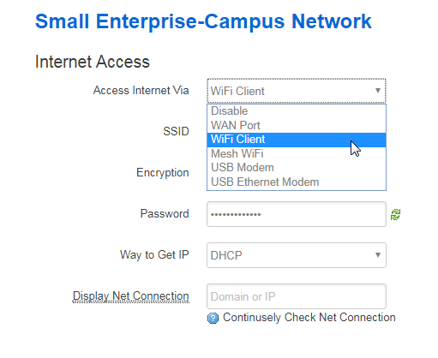

Step 7: Fill in the remaining network information, ie SSID, encryption type, password, DHCP or static ip

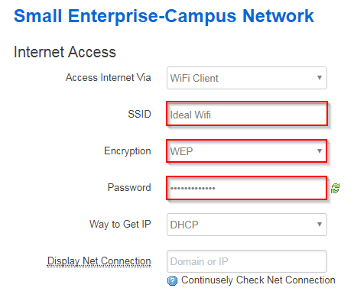

Step 8: Reconnect to original Wifi network and look for assigned ip address of Dragino gateway

In this case the assigned IP address is “192.168.254.15”. Entering this ip address in a browser will take you to the login page of the Dragino. This way you can modify the Dragino over WiFi so you don’t have to lose internet connection to change any settings on it.

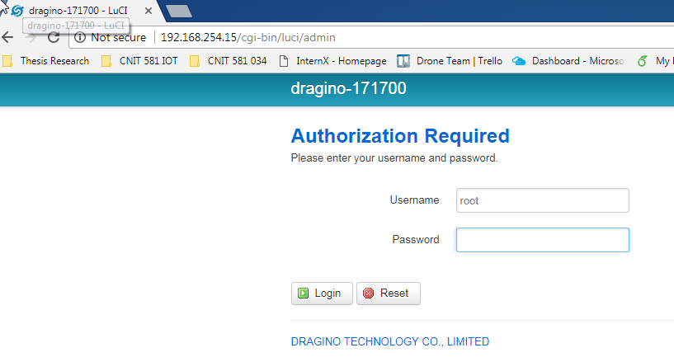

Step 9: Open the Arduino IDE and go to file -> preferences and enter <http://www.dragino.com/downloads/downloads/YunShield/package_dragino_yun_test_index.json> in the “Additional Boars Manager URLs:” box and hit “ok”

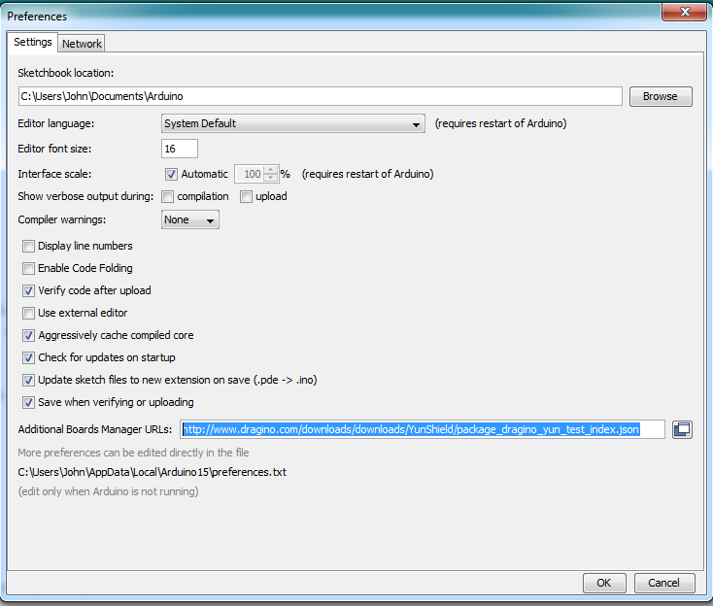

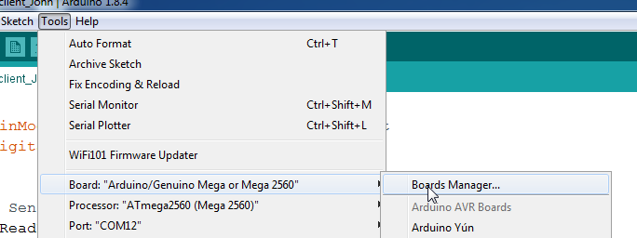Step 10: Go to the Arduino IDE again and go to Tools -> Board: -> Boards Manager and click on it

Step 11: The “Dragino Yun by Dragino Technology” should show up at the bottom of the boards manager list, click install and it should automatically download necessary library files for the Dragino board

In this case I already installed the library file:

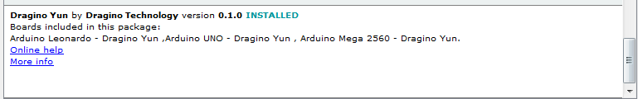

Step 12: Go to Tools -> Board: -> and at bottom select Arduino Uno – Dragino Yun

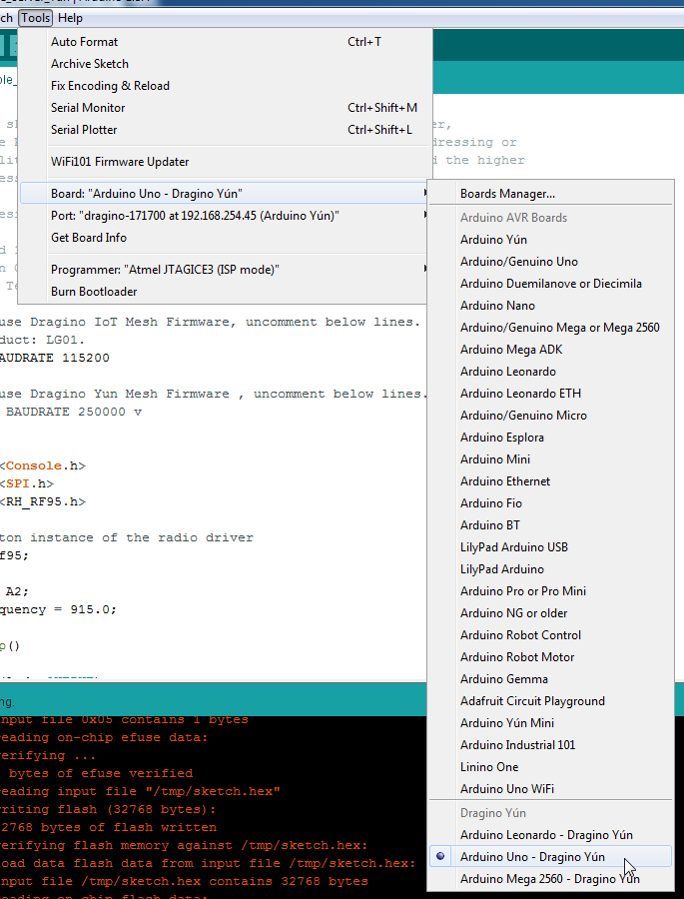

Step 13: You should now be able also to go to Tools -> Port: -> and be able to select the Dragino gateway at it’s specific IP address. Select to be able to write any sketches to the board.

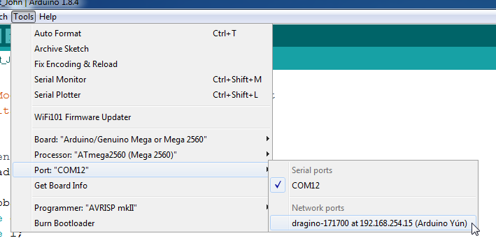

Step 14: Go to File -> Examples -> Dragino -> LoRa -> LoRa_Simple_Server_Yun

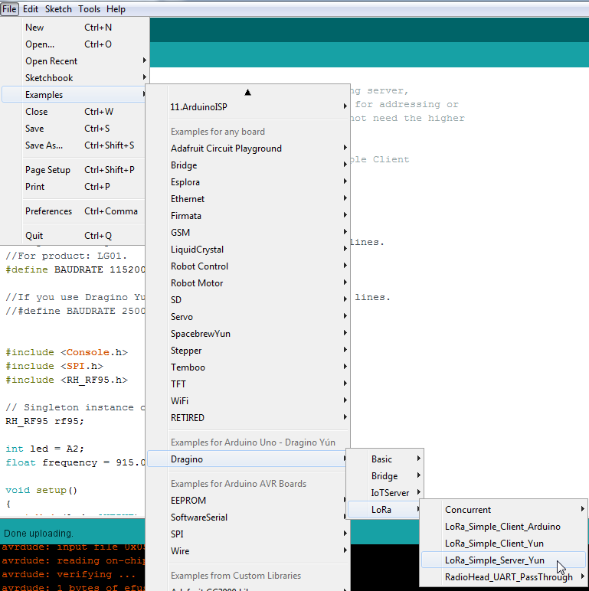

Step 15: Modify the LoRa_Simple_Server_Yun sketch to match the frequency of the LoRa client node.



Step 15a: Make sure to add the “RadioHead” library to Arduino, if you don’t have it already installed go to <https://github.com/dragino/RadioHead/archive/master.zip> and put it in the correct location to be used as an Arduino library.

Step 16: Upload the sketch to the Dragino gateway

**Part 2: Setting up Node/ LoRa Shield on Arduino Mega:**

Step 17: Plug in Arduino board with the attached LoRa shield.

Step 18: Go to File -> Examples -> Dragino -> LoRa -> LoRa_Simple_Client_Arduino

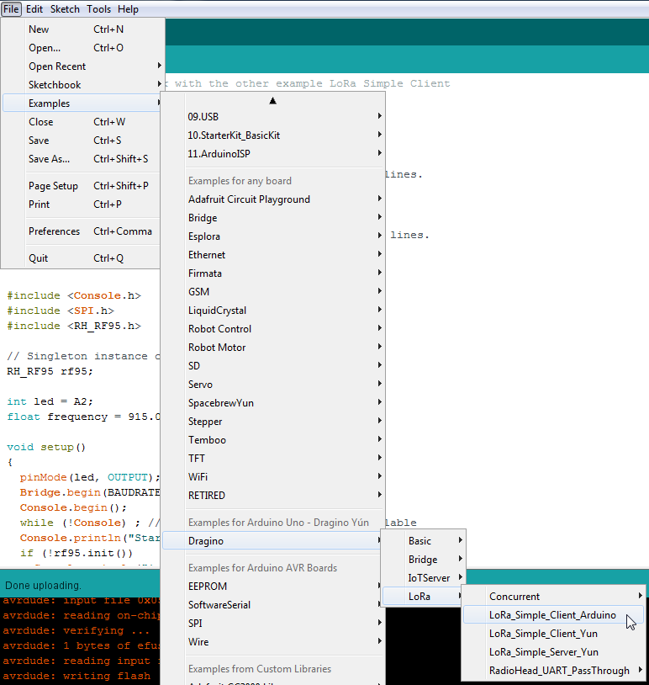

Step 19: Select the Arduino/ Genuine Mega or Mega 2560 Board from Tools -> Board and select the correct com port for where the Arduino is connected.

Step 20: Modify the sketch so that the frequency of the client matches the frequency of the server. In this case it is 915 mhz.



Step 21: Upload the sketch to the hardwired Arduino

Step 22: Go to the serial monitor and select the correct baud rate (9600 baud in this case) and you should see a stream of commands showing the two devices are communicating.

